**EDUCATION**

_________________________________________________

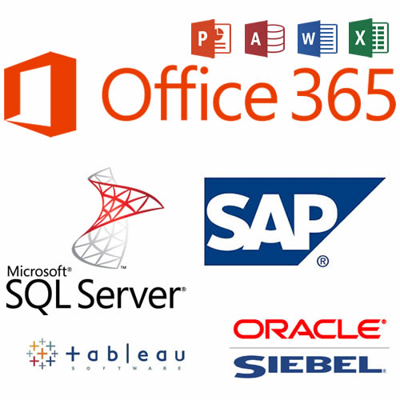

**MY EXPERTISE**

_________________________________________________

**PERSONAL STATEMENT**

_________________________________________________

I'm an experienced **Senior Customer Service Representative** based in Atlanta, GA. My work is always of the highest quality; I take on each customer call as though it were my own personal client. My expertise includes, but is not limited to Microsoft Office Suite (Office 365), SQL Server, Relational Database Management Systems, Siebel, Tableau, and SAP.

I’m punctual, creative, and responsible. I work well with management, peers, and customers/clients from all backgrounds. I am a consummate perfectionist at everything I do; I refuse to fail. I’m a perpetual learner; I’m always looking for new, more efficient ways of accomplishing tasks.

**BACHELOR OF ARTS IN BUSINESS ADMINISTRATION**

***Concentration in Finance***

CLARK ATLANTA UNIVERSITY

**RECOGNITIONS**

_________________________________________________

Analyst of the Year (2013) LeasePlan USA Internal contest (project based) |Alpharetta, GA $1,300 Payroll bonus

**HOBBIES**

_________________________________________________

**Additional Expertise…**

_________________________________________________

Web Development/Design

**Portfolio Link:**

[**https://atlantawebdesignsolutions.com**](https://atlantawebdesignsolutions.com)

Intuit, Domo, Infusionsoft, Adobe Catalyst, Survey Monkey, SQL, MySQL, PowerPivot, Office 365

**CAREER EXPERIENCE**

_________________________________________________

**Freelance Business Analyst (present job)**

+ **Develop analytical models** for search **marketing** clients

+ Design database tables and construct SQL queries for data extraction

**LeasePlan U.S.A.** From February 2012 to July 2014

**Sr. Procurement Analyst (2012-2013)**

+ Acted as a **liaison** between the company, finance department, and our vendors

+ Helped to **establish** and adhere to certain **purchasing guidelines** based on the strategies and goals outlined by LeasePlan and more specifically the finance department.

+ Regularly **composed RFI’s** (Request for Information) in order to invite service and merchandise suppliers to bid on projects.

+ **Negotiated the exact terms** of the agreement so as to establish clear expectations on the part of both parties.

**Comcast** From March 2011 to February 2012

**Business Support Representative (Business 2 Business Sales CSR)**

+ Processed orders and coordinated installation appointments with B2B accounts nationwide.

+ Resolved customer complaints by offering constructive resolutions that proved beneficial to both the company and Comcast.

+ Performed service troubleshooting for B2B customers over the phone and via screenshare.

**AT&T** From November 2004 to December 2010

**Supervisor, Retention Specialist (CSR)**

+ Senior Advisor to Management regarding the training and development of new recruits.

+ Helped reduced call Time to Completion by educating and providing immediate support to team members. Developed training material and coordinated lessons with HR.

+ Resolved phone escalations and general inquiries in an effective and efficient manner with a customer satisfaction rating of 92% YTD and Efficiency Rating of 90 % YTD.